COMPRESSION BETWEEN ARDUINO AND 8051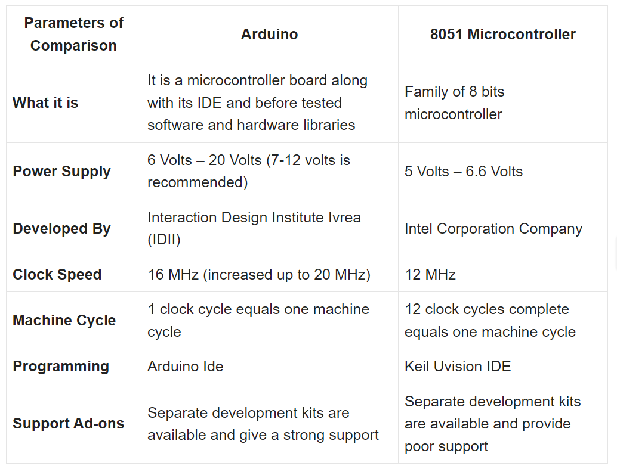

PIN DIAGRAM OF 8051:

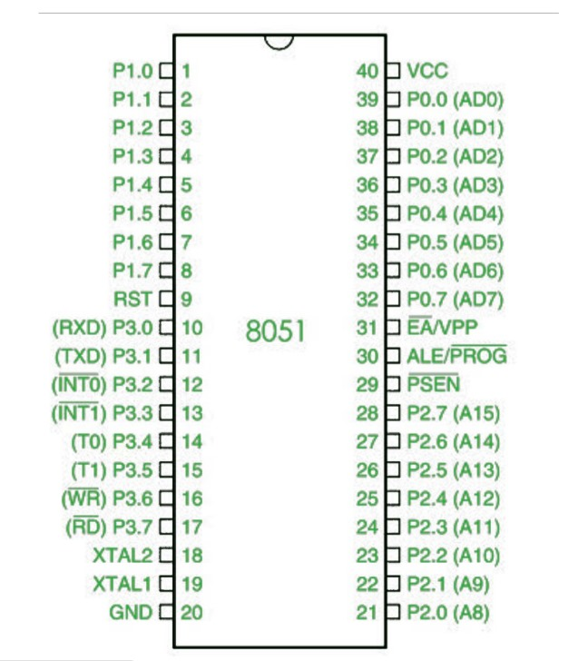

**Arduino pin description-**

